AUTONOMOUS BATTLE DAMAGE ASSESSMENT

Customer Test Requirements Verification
(v1.0-Final)

DOCUMENT HISTORY

DATE | STATUS | VER | AUTHOR | NOTES
20260407 | Draft | 0.1 | Carlos Gil | Created initial draft
20260408 | Draft | 0.2 | Carlos Gil | Added specific target platform
20260408 | Draft | 0.3 | Carlos Gil | Added reflection
20260409 | Draft | 0.4 | Carlos Gil | Unit link and workflow screenshot added
20260410 | Final | 1.0 | Carlos Gil | Final corrections added

Vision Language Models for Battle Damage Assessment

Customer Test Requirements Verification
Submission: 13 April 2026

Students
- Benjamin Siegel
- Carlos Gil
- Cory Wingate
- Nicholas Lind
- William Benitez

Supervisors & Mentors
- Dr. Rajneesh Singh
- Dr. Priya Narayanan
- Derrik Asher
- Jason Pusey
- CPT Jesse Barkley

1.0 Overview

This document describes the main features of the bda-svc system, delineates customer requirements, and demonstrates that customer test requirements have been met. This document also covers the acceptance criteria agreed upon by Army Research Laboratory (ARL) personnel. In order to contextualize this acceptance criteria, all relevant customer feedback and comments have been included.

2.0 System Overview

The system is a pipeline that analyzes images to automatically generate doctrinally-consistent Battle Damage Assessments (BDA) using Vision-Language Models (VLMs). Image files are imported from a camera onboard a mobile edge device that features an Nvidia Jetson Orin AGX platform. All images are then sequentially processed through a multi-stage inference pipeline.

Core features of this pipeline include target identification, object detection, input prompt customization, phase-one BDA report creation, optional phase-two functional-damage assessment, and image-scene summarization. The system generates output reports using a structured JSON BDA schema, formatted for integration into external systems. In addition to image processing and report generation, the system also supports an external software evaluation framework that enables comparison of different model variants against reference datasets with analyst-provided labels.

2.1 Customer Functional Requirements

To satisfy the operational needs of ARL, the system must fulfill the following functional requirements:

- User Interface: Provide a Linux-compatible Command-Line Interface (CLI) with help text, configurable pipeline via YAML files, and console status updates.

- Processing: Ingest single or sequential images, detect predefined objects (if any), and gracefully handle data extraction or processing errors.

- Analysis: Generate assessments of physical damage using doctrinally-aligned BDA templates, embedding metadata (such as datetime, model name, and input source) into the structured document containing the automated analysis.

- Reporting: Output syntactically correct and timestamped JSON files to default or user-specified directories, ensuring that prior assessments are not overwritten.

2.2 Customer Performance Requirements

Because the system is intended for use by mobile ARL edge devices, it must adhere to strict resource constraints:

- Data: Occupy no more than 2 TB of hard drive space and utilize a maximum of 64 GB VRAM during model processing.

- Speed: Determine the presence of a valid object in under 3 seconds and complete the full BDA analysis of a single image in under 45 seconds.

- Connectivity: Although limited networking resources are available, the system must operate as a standalone, self-contained application.

2.3 Customer Security Requirements

System access and data protection requirements mandate that:

- Network Isolation: The system operates entirely offline without external dependencies (other than onboard software systems).

- Permissions: The application is executable system-wide by standard (non-root) users and is only authorized read/write access to select input/output folders..

2.4 Customer Usability Requirements

- Ease of Use: The system must be simple for non-technical operators to use via standard CLI arguments.

- Resilience: The system must gracefully handle edge cases by routing to default input/output folders if none are explicitly provided by the user.

3.0 Test Execution Results

Testing was conducted continuously throughout the development lifecycle using two environments: local developer platforms for rapid software iteration and automated Continuous Integration (CI) via GitHub Actions on every push request. This hybrid approach ensured consistent validation across individual development environments and CI runners mirroring the target hardware.

Automated, pytest-based testing was conducted using eight distinct test scripts (test_cli.py, test_export.py, test_inputs.py, test_interfaces.py, test_main.py, test_model.py, test_utilities.py, and test_yaml.py) with the following results:

- Total automated test cases executed: 45

- Passed: 45

- Failed: 0

- Skipped: 0

The executed test suite achieved complete coverage of all prioritized customer requirements. Out of the 33 total requirements (15 Functional, 18 Non-Functional) defined in the Phase II Requirements document, all were successfully verified through either automated pytest execution, CI pipeline validation, or manual testing:

REQUIREMENT CATEGORY | REQUIREMENT | VERIFICATION METHOD | COVERAGE
User Interface (FR.U) | FR.U1, FR.U2, FR.U3, FR.U4 | Automated unit tests (test_cli.py, test_yaml.py) | 100%
Processing  (FR.P) | FR.P1, FR.P2, FR.P3, FR.P4 | Automated integration tests (test_inputs.py, test_main.py) | 100%
Analysis  (FR.A) | FR.A1, FR.A2, FR.A3 | Automated pipeline tests (test_model.py) | 94%
Reporting  (FR.R) | FR.R1, FR.R2, FR.R3, FR.R4 | Automated unit tests (test_export.py, test_utilities.py) | 100%
Usability  (NR.U) | NR.U1 - NR.U7 | Local exploratory testing & automated tests (test_inputs.py) | 100%
Performance (NR.P) | NR.P1, NR.P2, NR.P3, NR.P4 | Hardware validation via CI pipeline (build-and-run ARM64 job) | 100%
Accuracy  (NR.A) | NR.A1, NR.A2, NR.A3, NR.A4 | Automated unit tests (test_yaml.py, test_export.py) | 100%
Maintainability (NR.M) | NR.M1, NR.M2, NR.M3 | CI pipeline validation (Docker Buildx) & Version Control | 100%

Issues identified during both local exploratory testing and automated CI runs were managed collaboratively using GitHub Issues. Recent issues include:

GITHUB ISSUE | SEVERITY | PRIORITY | DESCRIPTION | IMPACT
77 | HIGH | HIGH | LLM as  a Judge  "429" Responses | The LLM as a Judge functionality was being rate-limited by cloud providers. Fixed by implementing exponential backoff timer to every failed request.
83 | MED | LOW | Bounding Box Discrepancies | Pipeline failed to handle different bounding box formats (ex. Qwen3 vs Gemini). Impacted structural JSON generation (FR.A2). Fixed in pipeline/model.py with updated processing logic.
73 | LOW | MED | Missing metadata field (inference time) | The system failed to capture processing time for every image. Impacted model evaluation metrics. Resolved by adding a new field to BDA metadata and generating from app.py..

4.0 Test Evidence

Automated pipelines and test scripts hosted on the project's GitHub repository verify that customer test requirements have been met.

- Test Scripts (pytest): The repository's tests directory contains the eight core Python testing scripts that validate system behavior, ranging from CLI input handling to report formatting. This directory may be found at https://github.com/cmu-bda/bda-svc/tree/main/tests.

- Test Data: End-to-end pipeline behavior was verified using developer-provided post-strike imagery, while automated testing relied on version-controlled, standardized test assets stored within the repository. YAML configuration files act as validated doctrinal sources.

- Execution Logs (CI Pipeline): The primary evidence of system compliance is the automated GitHub Actions Workflow summary (see Figure 4a), which successfully executes three sequential jobs on every pull request:

  - "test" Job: Operates within a standard Ubuntu runner (Python 3.12). This job Installs uv and project dependencies and executes the full pytest suite to verify core logic, utility functions, and YAML/JSON structural integrity.

  - "build-and-run" Job: This job configures Ollama, pulls a VLM model (qwen3-vl:2b-instruct), loads the test data, builds the container via Docker Buildx (targeting linux/arm64), and runs the BDA pipeline as an integration test.

  - "scan" Job: Operates within an ARM-based Ubuntu 24.04 environment. Performs security scans using the open-source tool Trivy.

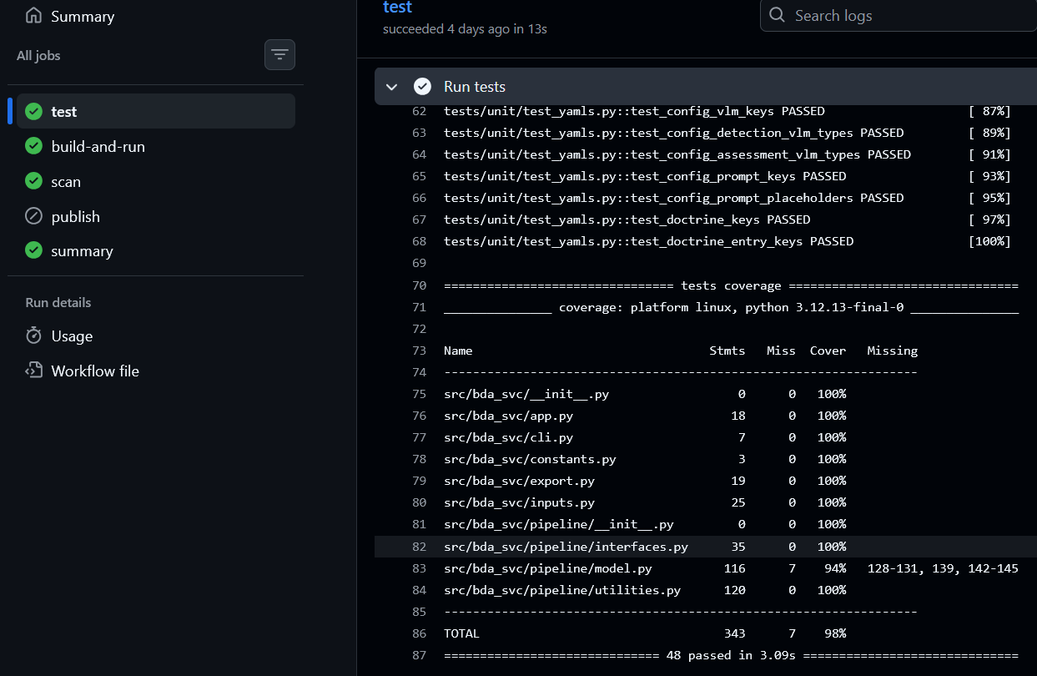
Figure 4a. GitHub Actions Workflow Summary

5.0 Customer Acceptance

Acceptance criteria were established in coordination with ARL stakeholders. For the system to be considered acceptable, it must:

- Generate syntactically correct, JSON-formatted BDAs strictly utilizing published military doctrine.

- Perform analysis completely autonomously and offline on an edge device.

- Operate within a Linux distribution as a console-based application.

- Process images sequentially and perform graceful error-handling.

During preliminary phases, key stakeholders emphasized the importance of receiving a doctrinally-compliant, VLM-based system able to run locally on edge devices and with minimal execution time. Feedback was incorporated by refining model prompts and restructuring the system to utilize backend model systems. The customer has confirmed that the generated assessments align with aforementioned requirements.

6.0 Conclusion

The test requirements verification process confirms that the bda-svc system successfully fulfills the project's scope. The system reliably ingests non-moving target imagery, processes data through a self-contained VLM pipeline, generates doctrinally-consistent BDAs, and exports standards-based JSON reports. The implementation of container-based modular design ensures that the pipeline remains maintainable and upgradeable for future ARL and external researcher experimentation. Although the target infrastructure provided an initial challenge, as it utilized an ARM-based processor, we were able to successfully build a package deployable to that target platform.

7.0 Reflection

Creating this document demonstrated the importance of maintaining proper communication with relevant project stakeholders. Without a clear line of communication, teams may fail to meet customer requirements (which are often vaguely or incompletely defined, at least initially).

Although we initiated contact with several ARL personnel at the project onset, we were not aware that key stakeholders were missing from those early discussions. This became problematic as complex requirements (such as the need to interface with backend servers) were added to the initial design later in the project timeline.

If we were to initiate this project again, we would heavily emphasize the need to identify all key stakeholders during the project scoping phase. By solidifying the acceptance criteria earlier, the decision-making process for our software architecture would have been much smoother. This, in turn, would have informed our testing strategy much earlier.

8.0 Appendix

8.1 Glossary

BDA (Battle Damage Assessment): An analysis that provides a timely and accurate estimate of damage resulting from the application of lethal and nonlethal military force..

pytest: A Python testing framework used to implement and execute automated tests in this project.

VLM (Vision-Language Model): A model capable of processing visual inputs (images) and generating language-based outputs

YAML (YAML Ain't Markup Language): A human-readable, indentation-based data serialization language.

9.0 Changes to Previous Deliverables

The JSON schema used by the system has additional fields to meet customer requirements. Specifically, every BDA report now includes a scene summary (which will facilitate efficient user notification) and model name (to aid automated model evaluation).

